Sprint - 2

|  |  |
| --- | --- |
| Date | 17 November 2022 |
| Team ID | PNT2022TMID18036 |
| Project Name | Smart Fashion Recommender Application |

Creating UI for Admin Admin Login:

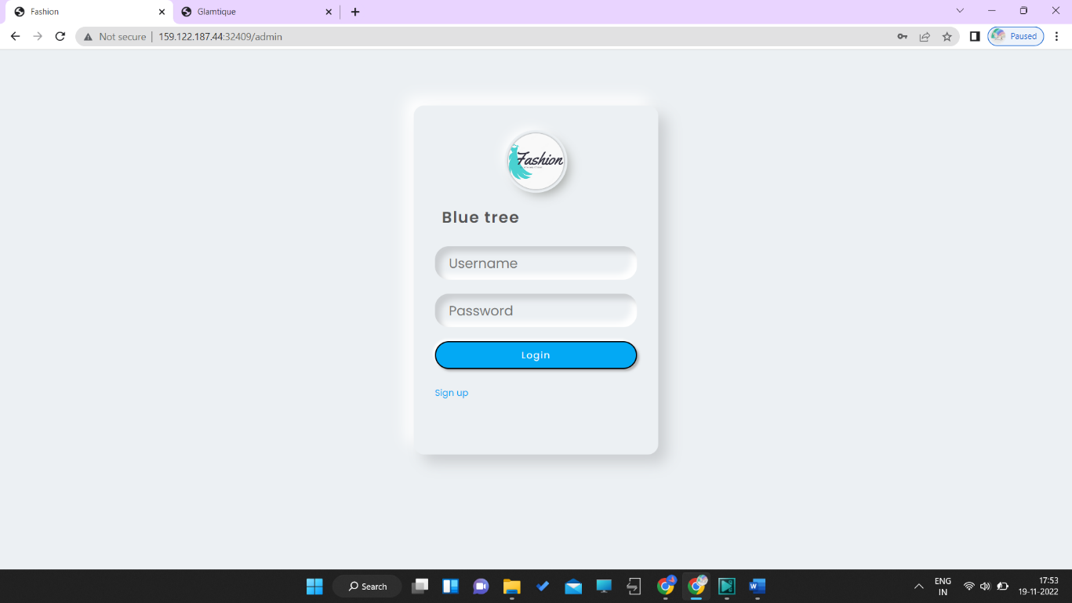

Admin Panel:

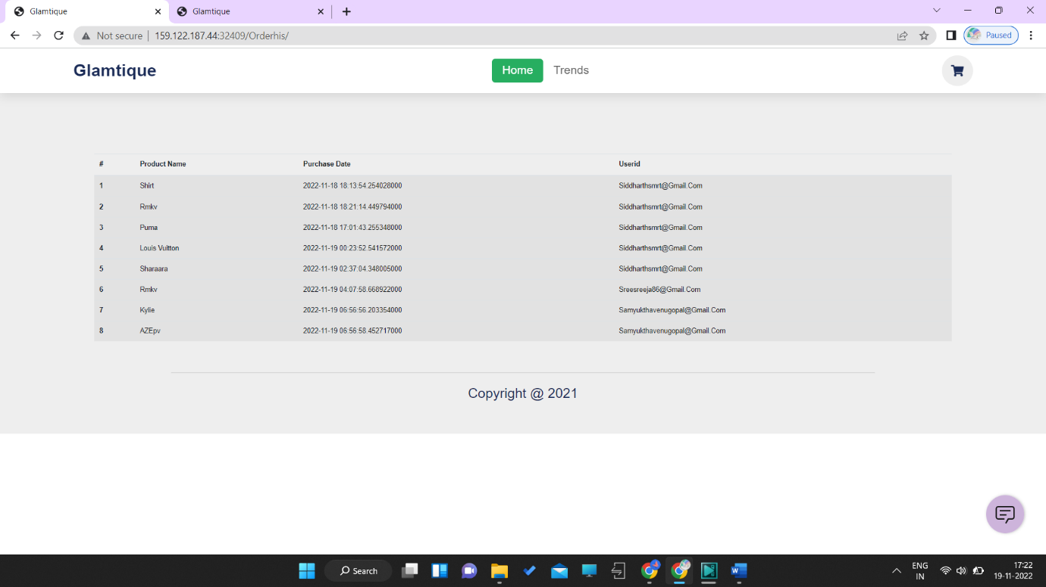

Creating database connection for admin panel:

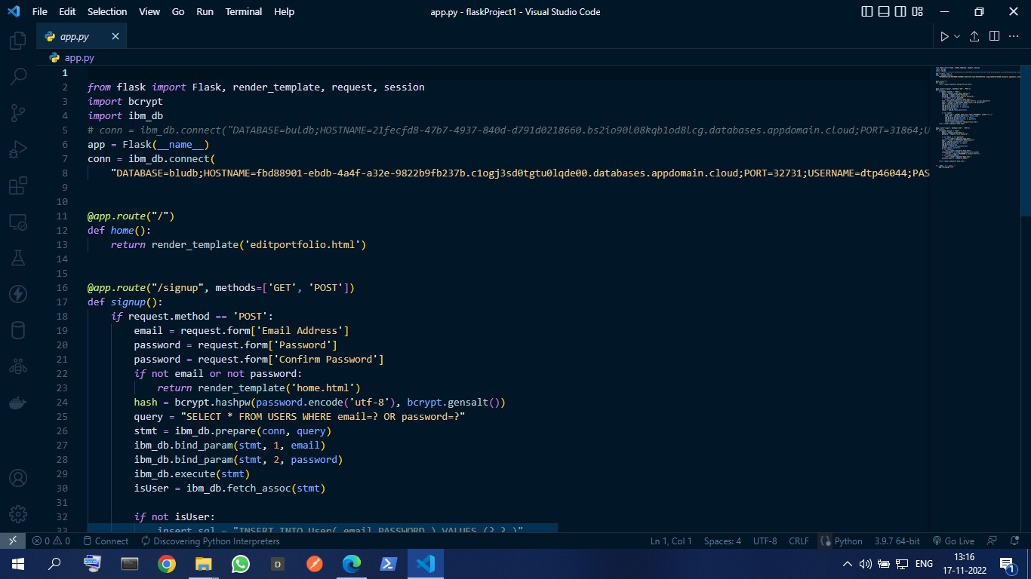

**Add products page:**

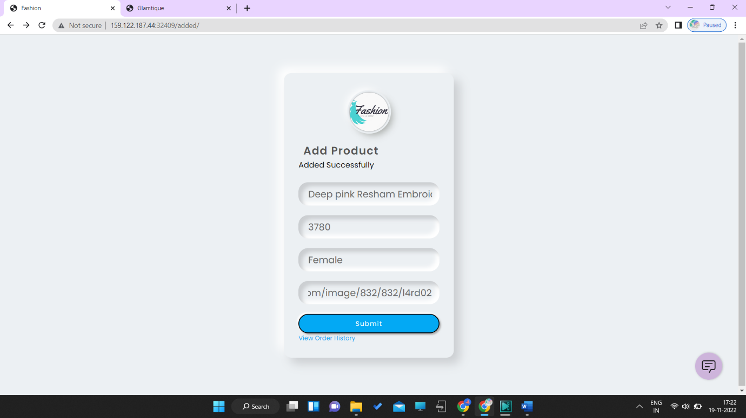

**Tracking all the orders placed:**

